Each of us is special to God and he wants us to be special to each other. Because God first loved us, we really need to love God and let that love show to others in the way we act toward them and the way we treat ourselves.

ST. PAUL’S COURIER

A PERIODICAL TO INFORM, ENCOURAGE AND SUPPORT MEMBERS OF OUR CHURCH,
FAMILY AND FRIENDS!

I pray that each of you will be filled with the peace that comes from knowing that you are loved…loved by God…and nothing, nor anyone else really matters. Remember, the good news I bring to you today is that you don’t have to do anything, be anything other than who and what you are to receive God’s love…it is already given to you…you just have to accept it!”
GOOD NEWS FOR EVERYONE
“There are times when each of us needs a reminder that God loves you. God loves you just as you are…He loves us not because we are good or wealthy or healthy or wise or deserving. He just does. God loves us period! Not because we are loveable either…we are loveable because God loves us! We are accepted by God just as we are. Many spend a lifetime trying to be good enough, do enough, or give enough when in the end…nothing has been enough to prove our worth. We often try to earn God’s approval and acceptance…The good news is there is nothing we can do to make God love you less…absolutely nothing you have done in the past or will do in the future that will turn God away from you. He loves you today, he loved you yesterday and he will love you forever. We were each created by God, like God, for God.

Humbly submitted by Alice Lewis, Associate Priest.
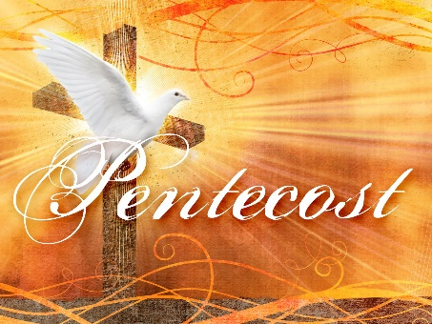
VOLUNTEERS
Everyone who attends our church is considered an important part of our church family. Without volunteers, we would not function nearly as well or as comfortable, as we do. Having said that, everyone is welcome and invited to contribute in whatever way they might like. If you would like to read lessons, do prayers, meet and greet, ring our bell, help the sexton, usher, offer special music, whatever your interest or talent might be…please, please let Rev. Alice or Fr. Russ know. Serving God and His Church is the highest form of worship
ANNOUNCEMENTS
When you have announcements for the bulletin, please write them on a sheet of paper and give to Sandy. For Sunday announcements, write on paper and give to Fr. Russ prior to the Worship Service.
If you are blessed with extra time, please consider giving the Gift of Time by becoming a Respite Volunteer. There are informational meetings describing the types of help needed. If you think you might be interested, please talk with Alice. Members of Respite Volunteers of Shiawassee believe in the dignity and worth of all individuals. Respect for the caregiving family. Hope, compassion and the integrity of others. Belief in the interfaith component and its strength. These are just a few of the values and they seem compatible with out Christian values, thus, volunteering is a good fit for members of St. Paul’s.
WEBSITE
Check out our website! (stpaulscorunna.org) and our facebook page. When someone is looking for a church home, the modern way is to search for a website. If you have ideas on how to better utilize these sites, please talk with Carol Amsterburg or Sandy Kirby. They are doing a superb job and would really like to expand the site. Your suggestions will be most helpful.
UPCOMING EVENTS
Third Sunday each month is birthday Sunday, celebrating everyone who had or will have a birthday. Cards are always a nice way to say Happy Birthday and a list of birthdays for each month will be posted on the bulletin board for your convenience. Remember we are a church family and called to love and celebrate each other.
September Birthdays are Deana Damn Edington, Irvine Smith, Carolyn Ford, Sandy Kirby and Gary Schooley
If you would like to give a card, but forgot to get one, there are several for you to use in the office. Please feel free to pick one out and present it to the honoree each month.
September 29th is “Each One Bring One Sunday”. Think now of someone you can invite. We are a compassionate, loving church home and would welcome back a lapsed member, a person new to our faith, or anyone will to come regardless of color, individual preferences or past history. We are commanded to love all people and sharing our faith is the ultimate test of our love. Let’s try to fill our pews on September 29th.
In an effort to know everyone a little better, we will have a light lunch and games following the worship service what better way to share God’s love than to share our blessings, and laugh together. Please take merrier our guests will feel more at ease being here!
The Harvest Dinner is coming up October 12. Details will be forthcoming. Volunteers are needed. If you would be willing to prepare the turkey, and organize the potluck, please speak with Alice. Other volunteers will be needed to set up the dining hall, clean up after dinner, serve the turkey, offer a pre-meal prayer, and arrange some form of entertainment. This is truly a family feast to which all are welcome. Don’t forget to INVITE!

FOOD FOR THOUGHT
Plant a Garden for Daily Living
Plant Three Rows of Peas…
Peach of mind…Peace of heart…Peace of soul!
Plant Four Rows of Squash…
Squash gossip…Squash
indifference…Squash grumbling…Squash selfishness!
Plant Four Rows of Lettuce…
Lettuce be faithful…Lettuce be kind…Lettuce be patient…Lettuce love one another!
No Garden is Without Turnips…
Turnip for meetings…Turnip for service…Turnip to help one another!
To Finish Our Garden We Must Have Thyme
Thyme for each other…Thyme for family…Thyme for friends!
Water freely with patience and cultivate with love. Our garden will be fruitful because we reap what we sow!

